TANZANIA TELECOMMUNICATION CORPORATION



EXTELECOMS HOUSE

32 SAMORA AVENUE

P.O Box 9070

11950 Dar es Salaam, TANZANIA

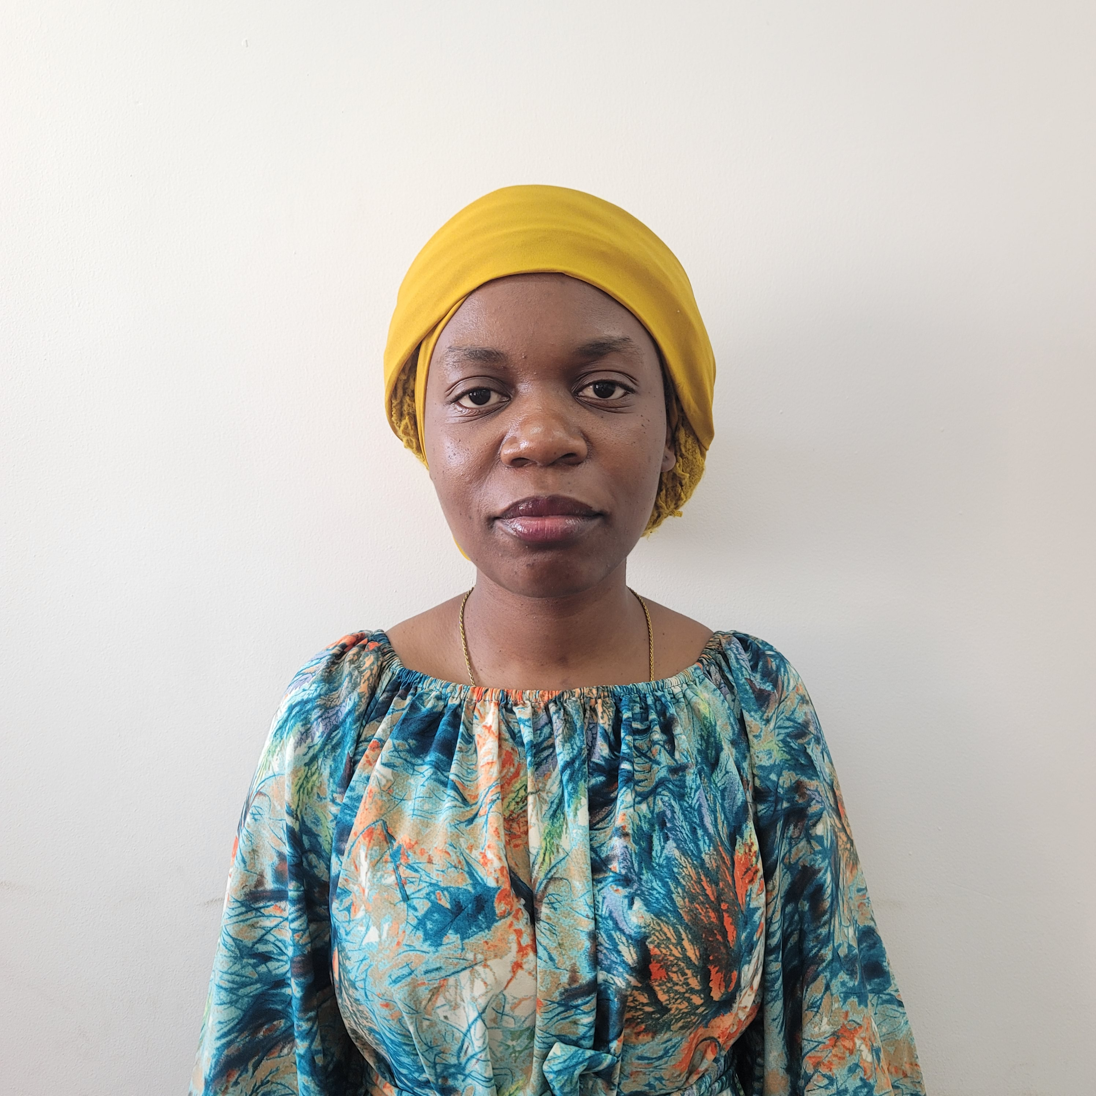

Telephone: +255(0) 222142000

Facsimile: +255(0) 22 2113232

Email: info@.co.tz

Website: www.ttcl.co.tz

PRACTICAL TRAINING STUDENT REGISTRATION FROM

STUDENT BIODATA:

**Surname**: WINDA

**Middle name**: ISSA

**First name**: WAHDA

**Date of birth**: 01st MARCH 2002

**Residential address**: KIGAMBONI

**Cell number**: +255 672791219‬

**Email address**: windawahda15@gmail.com

ACCREDITATION INFORMATION:

|  |  |
| --- | --- |
| **Accreditation Institution:** | UNIVERSITY OF DODOMA |
| **Registration number**: | T23-03-17988 |
| **Student Program:** | BACHELOR OF SCIENCE IN SOFTWARE ENGINEERING |
| **Duration**: | 21st JULY 2025 – 12th SEPTEMBER 2025 |
| **Sign & Stamp:** | ………………. |

Rudi nyumbani kumenoga

**CODE OF CONDUCT FOR PRACTICAL TRAINING STUDENT**

As a practical training (PT) student at TTCL, you will be expected to act in a professional and ethical manner. Your conduct should make TTCL want to host interns from your institutions in the future.

The following is expected of you as PT Student to TTCL

* Do not move any equipment unless instructed so by your PT Supervisor
* Do not misappropriate TTCL property
* Identification cards should be won at all times when it TTCL premises
* Remain drug and alcohol free and avoid to use of controlled substances
* Maintain confidentiality if work-related projects and personnel
* Familiarize yourself with, and adhere to relevant organizational arrangements, procedures, and functions
* Understand what constitute a permissible work absence and who to notify if absent, be prompt with being on time to work and with assignment
* If you feel victimized by a work-related incident contact the TTCL Training Coordinator immediately
* Dress appropriately for the work settings
* Follow through commitments
* Do not conduct personal business during work hours (email, cell phones, internet)
* Communicate- keep people informed in a useful and succinct way, listen , and ask questions
* Seek feedback from your supervisors, accept suggestions for corrective changes in behavior and attempt to improve performance
* Accept constructive criticism and continuously effectiveness by improving skills and acquiring new knowledge
* Seek to enhance your professional effectiveness by improving skills and acquiring new knowledge
* All PT costs shall be borne by the student and his/her training institution

Rudi nyumbani kumenoga